To create an XML Folder device,

From within the MUSE application, go to System->Setup->Devices and then at the top of the screen, click on Action and New
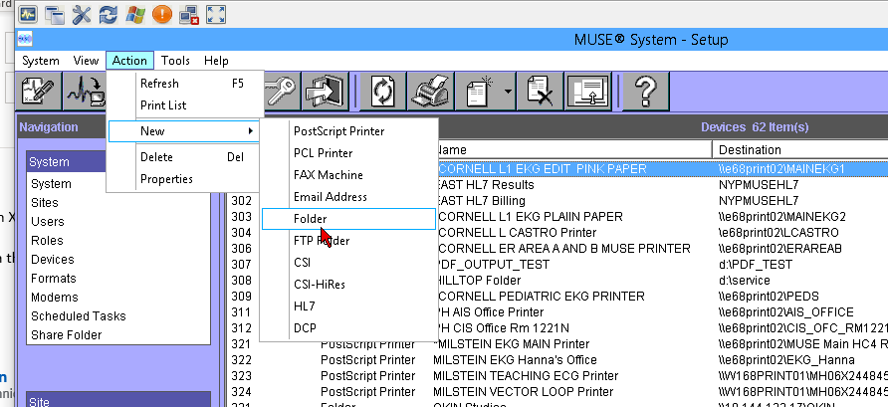

The device properties window will open and this is where you will configure the device.

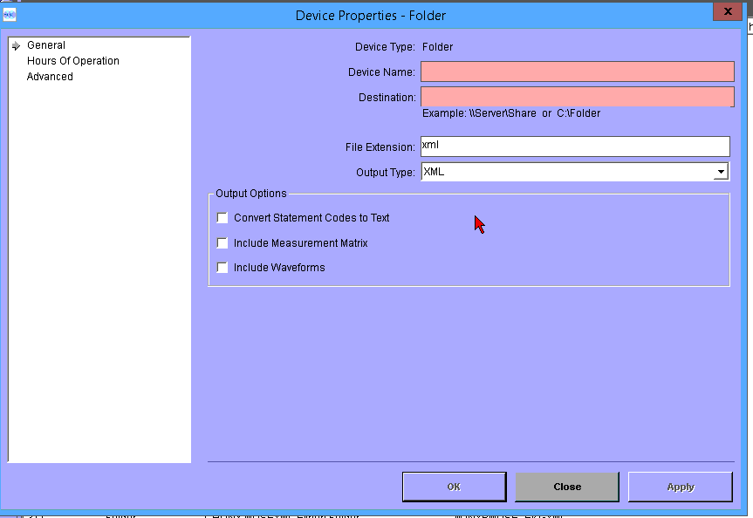

Device name is the name that the device will have in MUSE.
Destination is the network share or location of where you will write the data. The user that is starting the muse file copy service on the muse application server(NYH\musebkgnd_svc) needs to have full permissions to the folder you are sending/writing the data to or it will not send the files to that location.

File extension and output type should be XML
Under output options, check which options you need.
Hours of operation and advanced can be left at the defaults and then click ok

For the DBS, go to system->Database Search.
Click on action and new and you can then create a custom search using all of the parameters you need. There are 10 template(canned) searches that can be used also.
To print to the folder device, under printing in the DBS, choose the folder device you created.

Setting Up auto-XML export for future EKGs

Yes, that is in the GE MUSE Setup under Report Distribution, see an example below, this is set up to send an XML file both on demographics complete (ADT or Order info attached to an ECG) and when confirmed by a physician.

